|  |  |
| --- | --- |
| Key Vocabulary | |
| Nomads | A group of people that travel from place to place to find fresh [pasture](https://www.google.co.uk/search?safe=active&sca_esv=c4335f32e922ee13&q=pasture&si=ACC90nypsxZVz3WGK63NbnSPlfCB865l8gIUqS_355fvTXrhV-K2wdT-h692yBuGKu9nEVHaYUXO7yXEwRE8OYynZ_6dwW7nAQ%3D%3D&expnd=1&sa=X&ved=2ahUKEwjpzomGhsiIAxUOZ0EAHf1gAmEQyecJegQIKBAO) for its animals and has no permanent home. |
| Agriculture | The practice of farming, including cultivation of the soil for the growing of [crops](https://www.google.co.uk/search?safe=active&sca_esv=c4335f32e922ee13&q=crops&si=ACC90nwXlEU2j3qee_ajN1FbIPWBdQWJEKlhiNSf63jLY6RRvqfGCZgUrmCYvBYgu1-YglZy8VgeBpcUrHjL9HSRSqAZU_dpDw%3D%3D&expnd=1&sa=X&ved=2ahUKEwibke2KisiIAxWCQ0EAHTHGCvIQyecJegQIOxAO) and the [rearing](https://www.google.co.uk/search?safe=active&sca_esv=c4335f32e922ee13&q=rearing&si=ACC90nypsxZVz3WGK63NbnSPlfCBTjM0OQWqCYq2pyWAJ7oMYcbURM4bml_B0GN07lW98ch-qoT1H8QiblDEqjMeEL4IGknR-A%3D%3D&expnd=1&sa=X&ved=2ahUKEwibke2KisiIAxWCQ0EAHTHGCvIQyecJegQIOxAP) of animals to provide food, wool, and other products. |
| Trade | The action of buying and selling goods and services. |
| Settlers | A person who moves with a group of others to live in a new country or area. |

**What I already know, that will help me**

Year 2 Transport – We learnt nomads had to walk

**What will this help me with in the future?**

To compare and contrast settlements of Ancient Egyptians (Year 3), Ancient Greeks (Year 3), Romans (Year 4), Benin (Year 5).

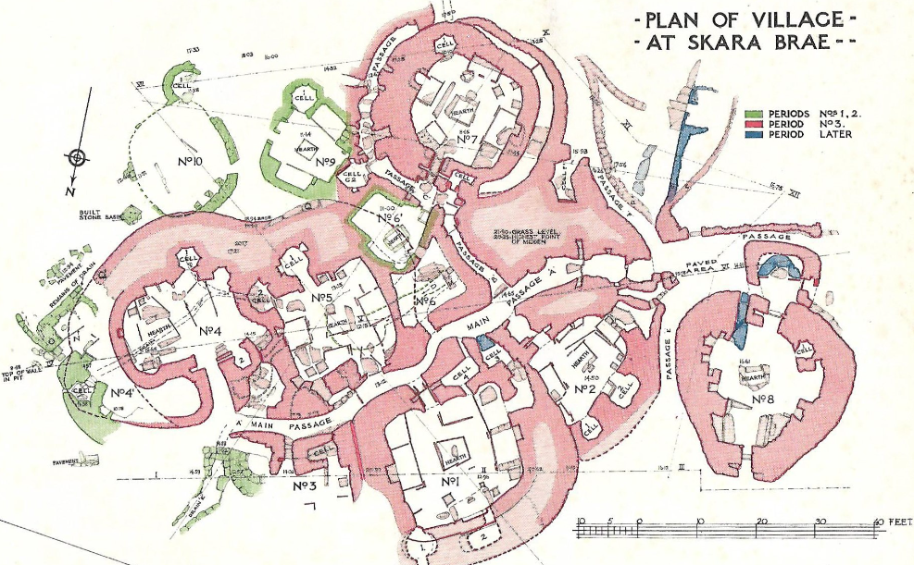

**What will I learn?**

15000-3000 BC Stone Age 3000BC – 8000BC Bronze Age 800BC – 43 AD Iron Age

2500 BC ‘Bell Beaker’ culture arrives in Britain. These people are named for their distinctive decorative pottery

AD 43 The Romans invade Britain.

800 BC Iron begins to be used in Britain to make tools and weapons, instead of bronze.

2100 BC Bronze begins to be used in Britain to make weapons and tools.

3000 BC The village of Skara Brae is built in Orkney.

Democracy Rule Trade Warfare Knowledge

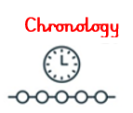 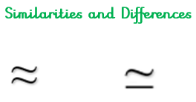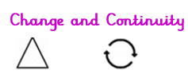 

**Disciplinary Concepts** *How Historians work*

* Chronology
* Significance
* Cause and consequence
* Change and continuity
* Similarity and difference

**Substantive Concepts** *The content knowledge*