Year 1

**What I already know:**

* When I was born
* The human lifecycle – stages from a baby to a child to an adult.
* That my family have grown up and changed.
* That I have grown and changed.
* Know some similarities and differences between things in the past and now.

**What will help me with in the future:**

Understand Equality- (Year 6 ) WW2 in Britain – stereotyping of men and women during WW2 and suffrage – gender stereotypes- stereotyping of black people linking to Rosa Parks (year 2 )– slavery (year 5)

Understanding Trade- where do our modern toys come from? Linking to traders like Vikings (year 4) Slave trade (year 5)

How have toys changed over time?

|  |  |
| --- | --- |
| Key Vocabulary | |
| Old | Belonging to the past. |
| Modern | Belonging to the present. |
| Past | It has already happened. |
| Equality | Everybody is treated the same and has the same rights. |

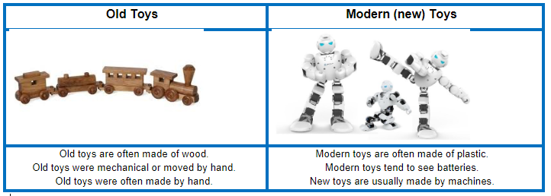

**Disciplinary Concepts** *How Historians work*

* Chronology
* Significance
* Cause and consequence
* Change and continuity
* Similarity and difference

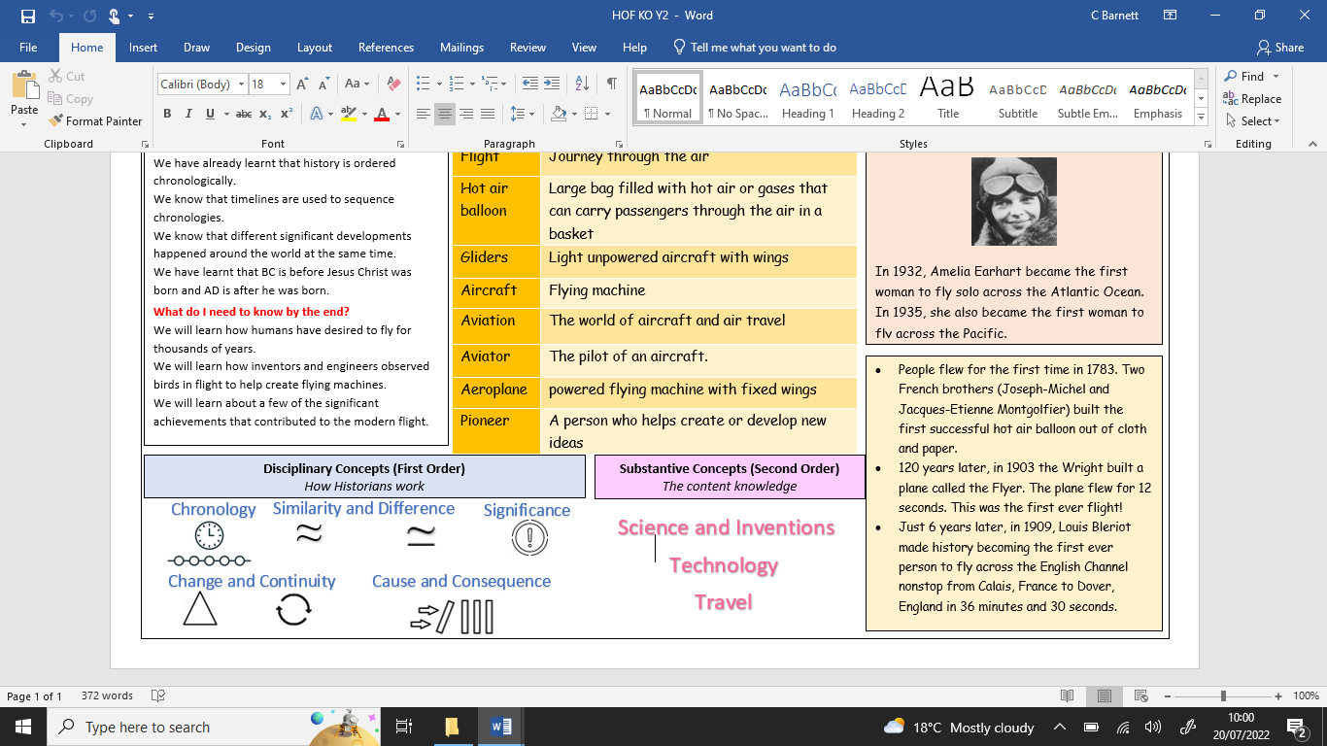

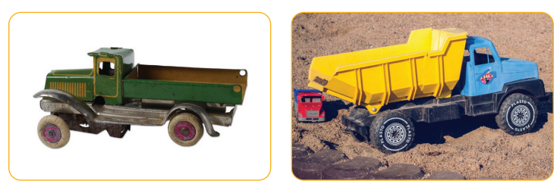

Democracy Rule Trade Warfare Knowledge

**Substantive Concepts**

*The content knowledge*

**What will I learn?**

* Toys have been around for thousands of years.
* Toys have changed and developed over the years.
* The way toys are designed and the materials used to make them have changed.
* The material, design and technology of a toy can give us clues about whether it is old or new.
* How to identify whether a toy is old or new.