**Year 2 – The Great Fire of London**

**What I already know that will help me:**

* The fire brigade are people that help us, and they use water and special equipment to put out the fires.

**What will this help me with in the future?**

* Y6 - What was the impact of the second world war on Salford?  - The Manchester Blitz

What changes did the Great Fire of London

|  |  |
| --- | --- |
| Key Vocabulary | |
| Diary | Where someone writes about events. |
| Eye witness | Someone who saw an event happen. |
| Maid | Someone who works in someone else’s house. |
| Water squirts | An item used to put out fire in 1666. |

bring?

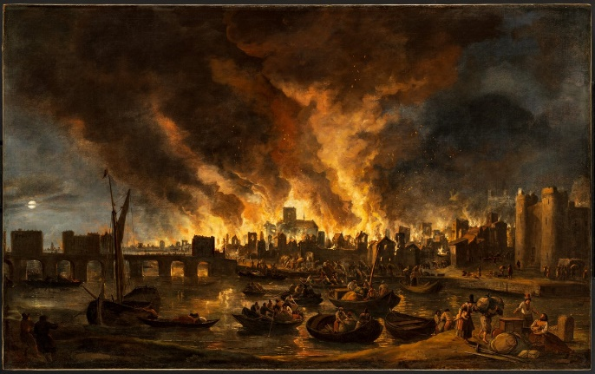

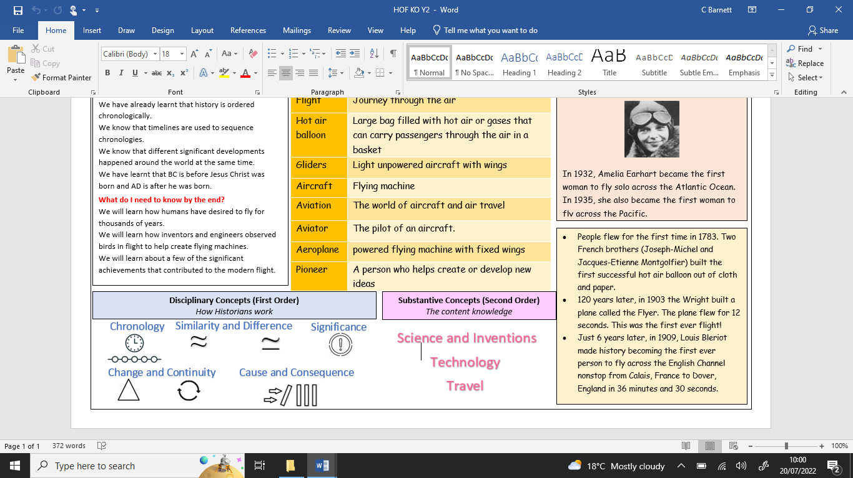

**What will I learn?**

* The Fire of London took place in 1666. Samuel Pepys wrote about the fire in his diary.
* Thomas Farriner was a London baker who left his bakery fire uncovered on the night of the fire in Pudding Lane.
* Houses burned easily because they were made from wood and straw.
* To fight the fires during this time, people used leather buckets and water squirts.

**Disciplinary Concepts**

* Chronology
* Significance
* Cause and consequence
* Change and continuity
* Similarity and difference

**Substantive Concepts**

Empire Equality Trade People of significance and their impact