|  |  |
| --- | --- |
| Key Vocabulary | |
| Air raid | An attack in which bombs are dropped from an aircraft to a ground target |
| Conscription | Compulsory enlistment into the armed forces. |
| Evacuation | Leaving a dangerous place and moving to somewhere safer. |
| Rationing | Only allowing people to have a fixed amount of something, e.g. food. |

Year 6

**What was the impact of the Second World War on our local area?**

**What will I learn?**

* The Second World War was caused by a series of events that began at the end of WW1 with the treaty of Versailles.
* British children were evacuated from their homes due to the risk from German air raids.
* The roles of women changed significantly during the war as most men were conscripted into military service.
* Changes to the British food supply meant that rationing had to be implemented, limiting the amount of food each person was allowed to buy.
* **What will this help me with in the future?**
* In KS3 I will study:
* Why the world went to war in 1914 (WW1).
* Who or what was responsible for the outbreak of the Second World War in 1939.

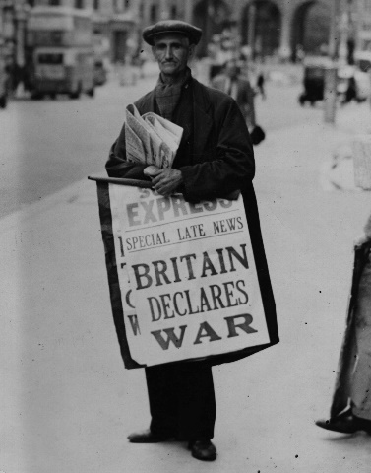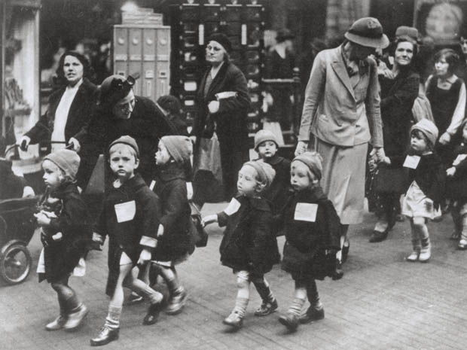

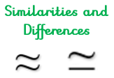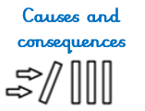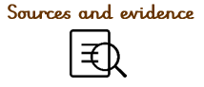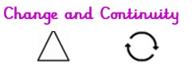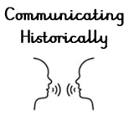

**What I already know that will help me:**

* The Industrial Revolution created jobs in factories and expanded the rail network around Great Britain.
* British colonies produced food, which was imported into Britain by boat.

Significant People

Trade

Equality

**Substantive Concepts**

*The content knowledge*

**Disciplinary Concepts** *How Historians work*

* Chronology
* Significance
* Cause and consequence
* Change and continuity
* Similarity and difference