|  |  |
| --- | --- |
| Key Vocabulary | |
| century | A division of the Roman army made up of 80 soldiers and led by a centurion. |
| Emperor | A sovereign ruler of an empire. |
| Empire | A group of states or countries ruled over by a single monarch or a sovereign state. |
| Legion | The main unit of the Roman army Senate (a group of prestigious men who advised the consuls. |

**What I already know that will help me:**

* Florence Nightingale, LS Lowry and Rosa Parks were significant people who fought for change and equality.

**What will this help me with in the future?**

Boudicca – links to equality and people creating change and how they approach it with Suffrage (in year 6)

Empire – Links to later in year 4 empires can become powerful because they had good traders like the Vikings.

**Understanding is developed in year 5 When looking at the invasion of Benin- empires can have colonies-made slaves of people they rule.**

**Year 4**

**What was the legacy of the Romans?**

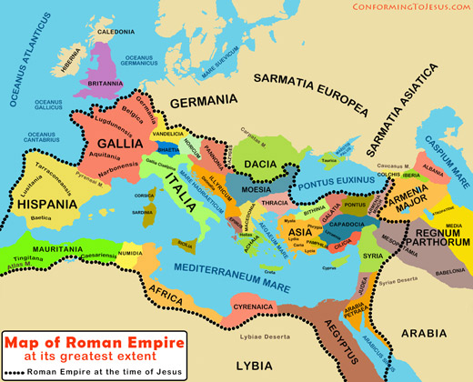

**What will this help me with in the future...**

* 43AD Romans invade Britain and it becomes part of the Roman Empire.
* 401-410AD The Romans withdraw from Britain: Anglo-Saxon migrants begin to settle.
* 61AD Boudicca leads the Iceni in revolt against the Romans.
* Romans influenced coins, trade, and road influences.



**Change and Continuity**



**Similarities and Differences**



**Causes and consequences**

**Chronology**



**Disciplinary Concepts**

* Chronology
* Significance
* Cause and consequence
* Change and continuity
* Similarity and difference

Empire Equality Trade People of significance and their impact

**Substantive Concepts**